Assignment #4 B: Interactive Music Video with Animated Character

Report

Guided by Professor Rachel McDonell  
Implemented by: Yuzhou Shao  
Student id: 19322035  
Youtube Demo: <https://youtu.be/BkRk2OR1pjs> (with a 52 seconds long shot in the beginning)

**Abstract:**

I developed this assignment project by Unreal Engine 4. I imported the free UE4 resource of the Hero named Wukong, the enemy named Khaimera and the default ThirdPerson character. I also imported the Scene called LVCave from UE4, based on this scene, I constructed and modified the environment by my own. These all are free assets.

But I constructed the movie by my own through a Cinematic Camera Actor and build the game logic of the imported skinned character also by my own.

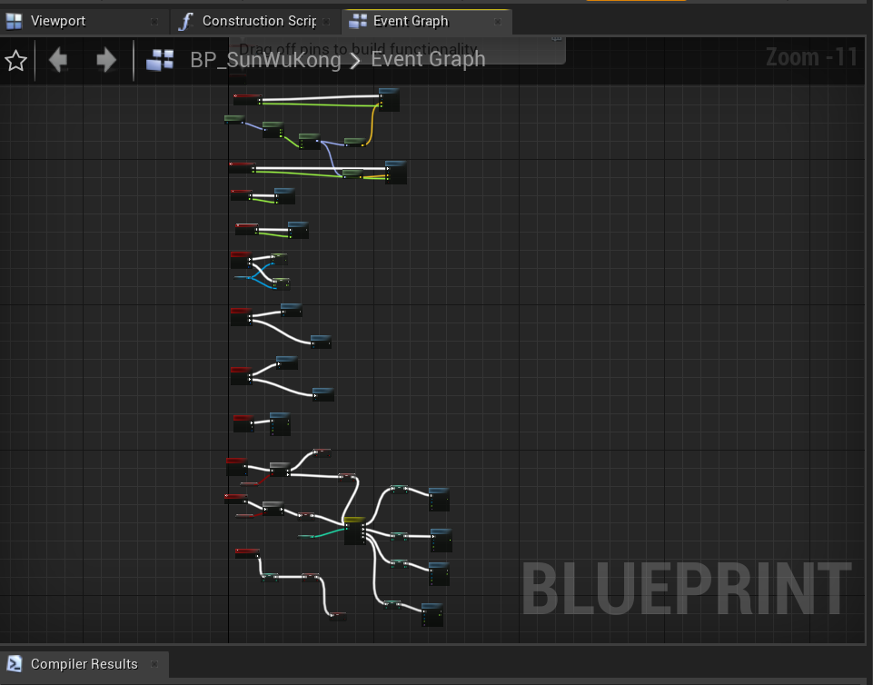

Above is one of the blueprint I constructed.

**Description:**

I have clearly implemented Squash and Stretch, Ease in, ease out, Arcs, Anticipation and Exaggeration on my project, which is presented in my Youtube demo video <https://youtu.be/BkRk2OR1pjs> ,for example:

**Squash and Stretch:**

If the hero waves this weapon and hit the stone ground. The stone and dust was crashed, squashed or stretched. The weapon stick is also squashed or stretched during attacking pose.

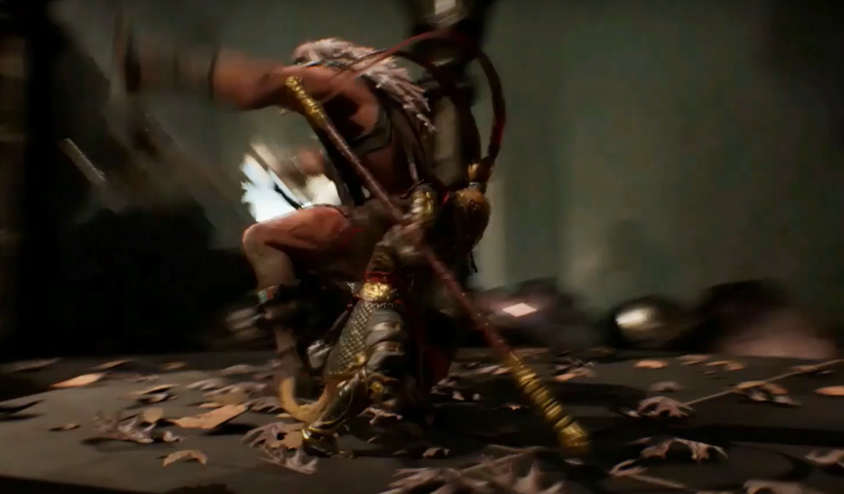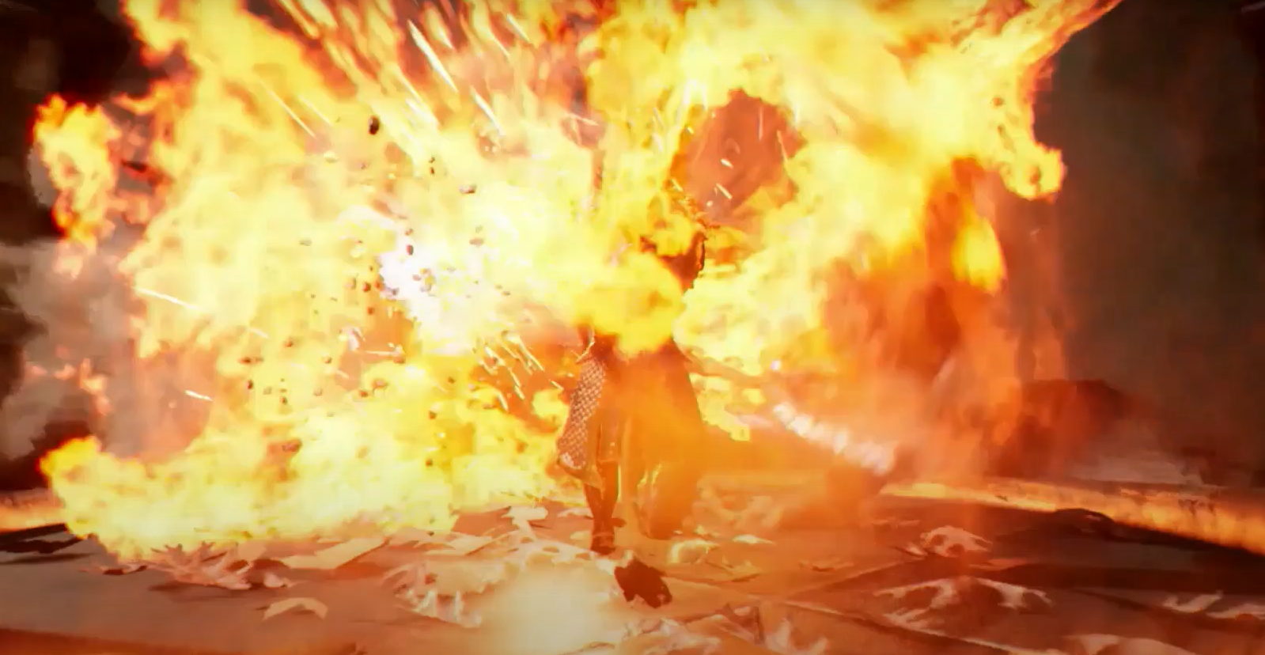

**Exaggerating:**

I used blend space or Motion State Machine to make and modified the action or posing, to make it exaggerating. Below is one or my example at the end of the video while the enemy is dying.

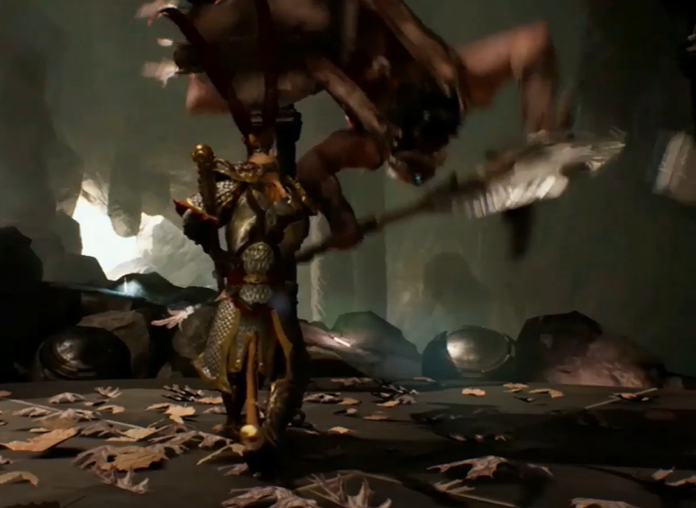

**Ease in and Ease out:**

I have implemented ease in and ease out through Sequencer by changing different non linear track of the camera. This presented clearly starting from 0:14, the 14th second of my Youtube demo, <https://youtu.be/BkRk2OR1pjs?t=14>.

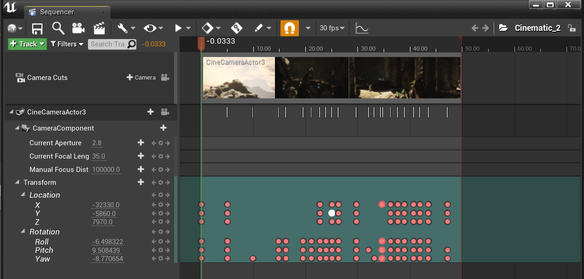

**Arcs:**

I have implemented Arcs through blendspace1d and writing the blueprint, the make the action walking for the hero more realists. In my Youtube demo, while the hero starts jogging from static, he has an action to ready and then jog, instead of suddenly jogging very fast from standing.

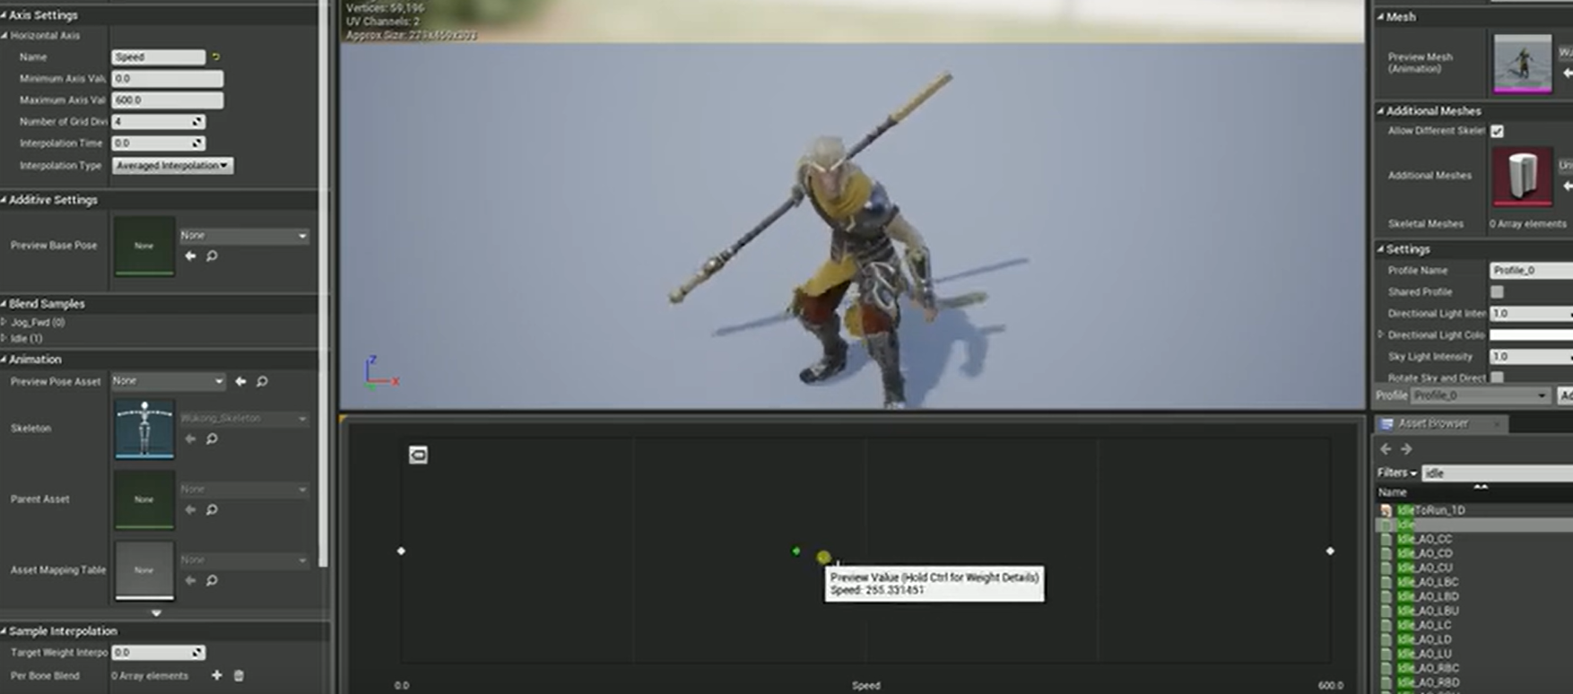

**Anticipation:** When the hero jumps, he has an action to ready and then jump.

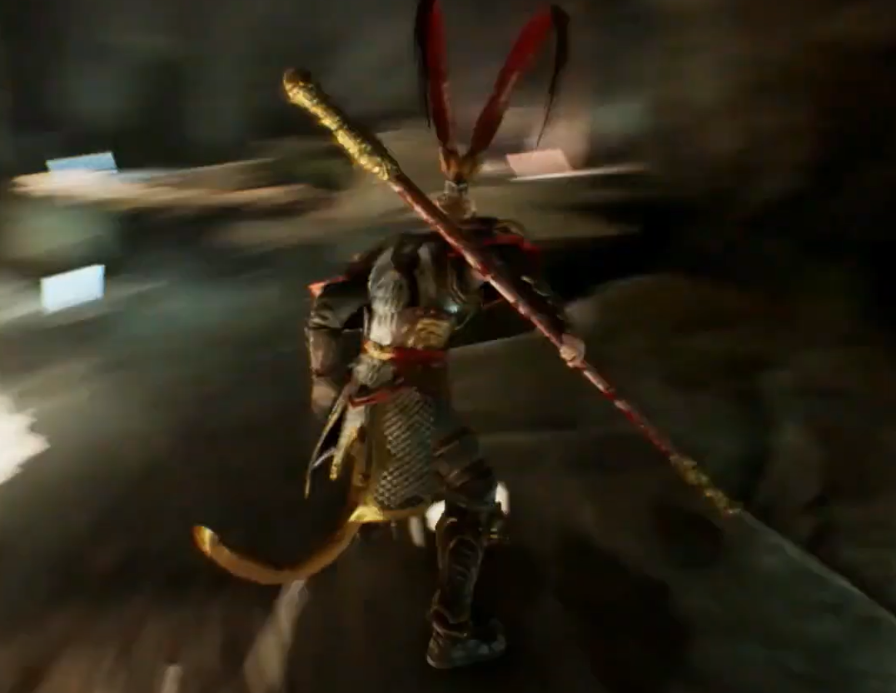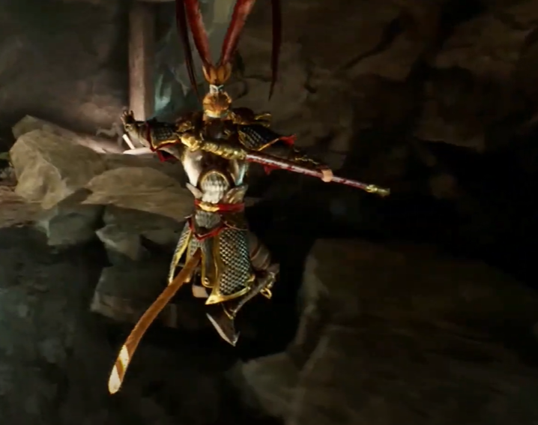

Features I have implemented:

**3D objects and views**

**Longer than 30s**, mine is 2 minutes and 47 seconds

**Non-Linear animated camera path** through Cine Camera Actor

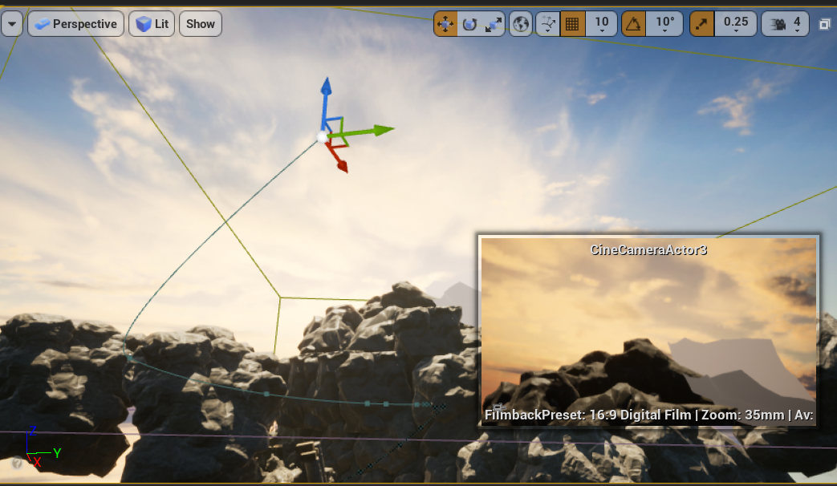

**Motion State Machine**, below is the screenshot of one of my state Machine

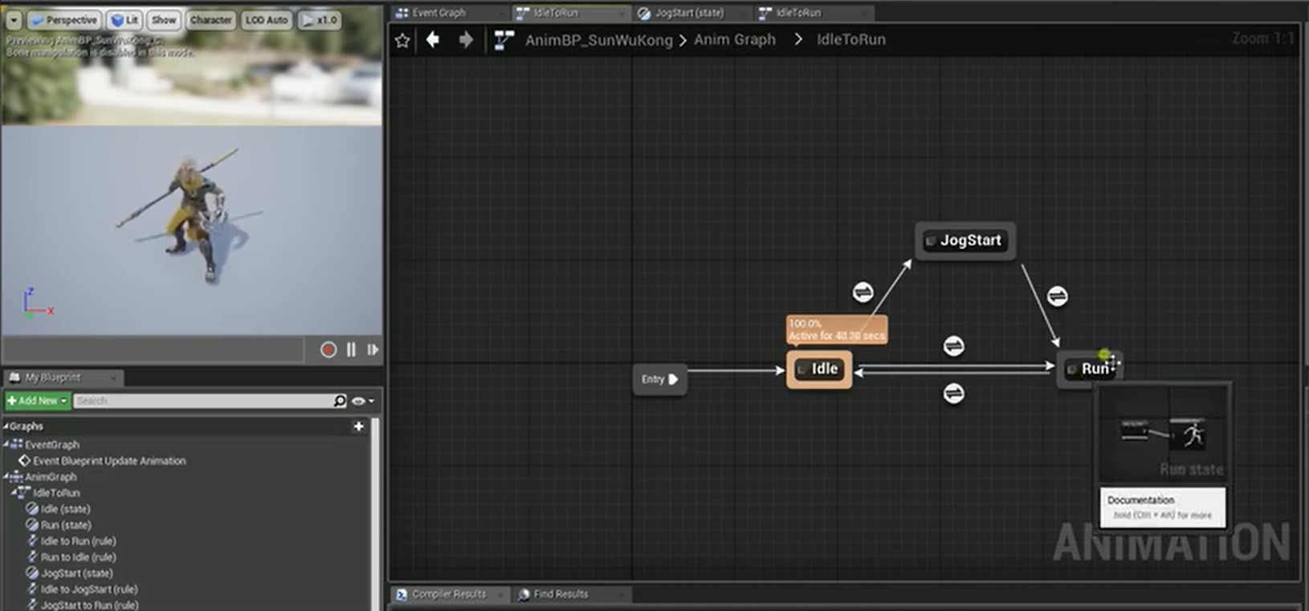

**Stylized Motion**

I used Montage edited different pose with inserted audios. And also wrote the blueprint.

Below is an example of the setting of my montage of a very classical pose of the hero Monkey King.

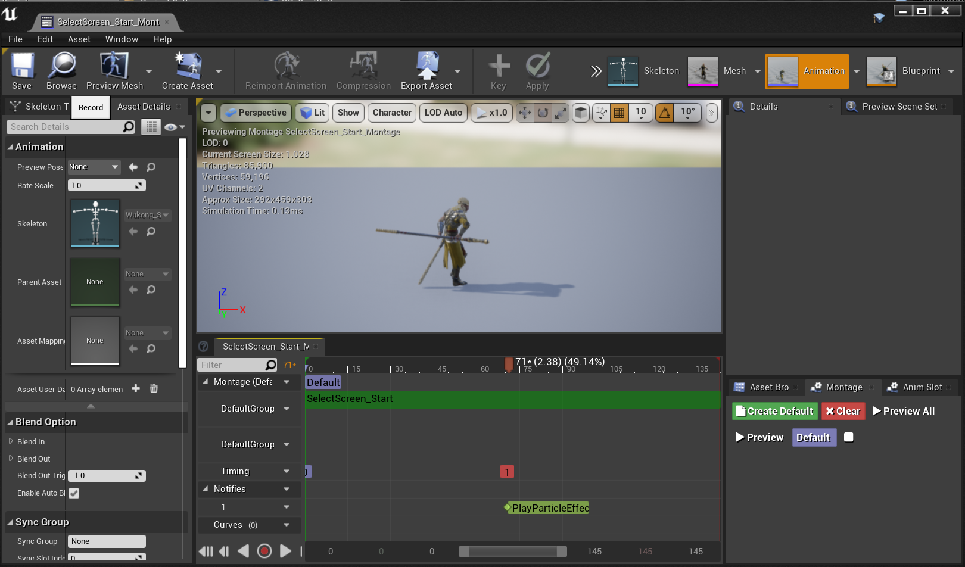

This is the output of a stylized motion.

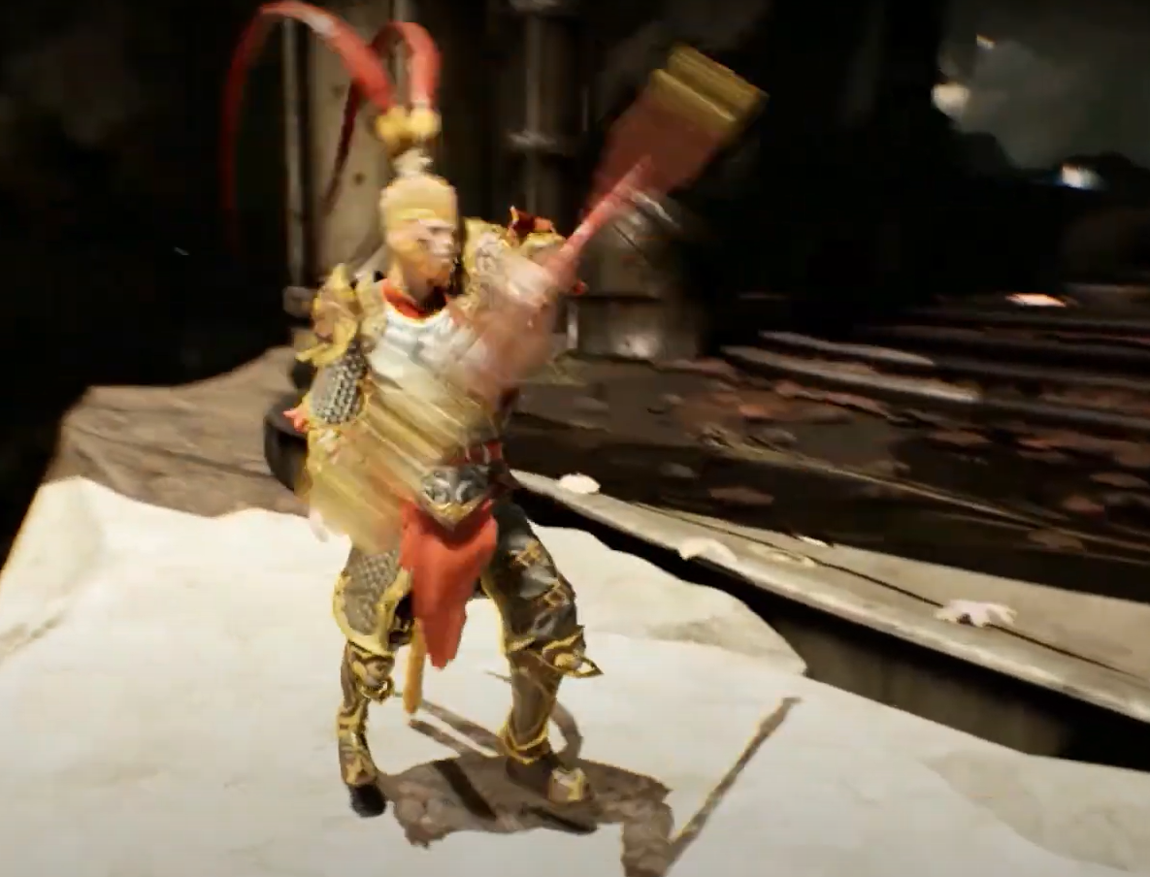

Have a **reasonably realistically moving articulated animated character**, as part of the line and visible during the camera path.

**Principles of animation**: Montage, the motions of crunch, jump, attack and posting of the hero. The motion of attack, react to hit, provoking and death of the enemy, seeing the end of my demon, below are two examples.

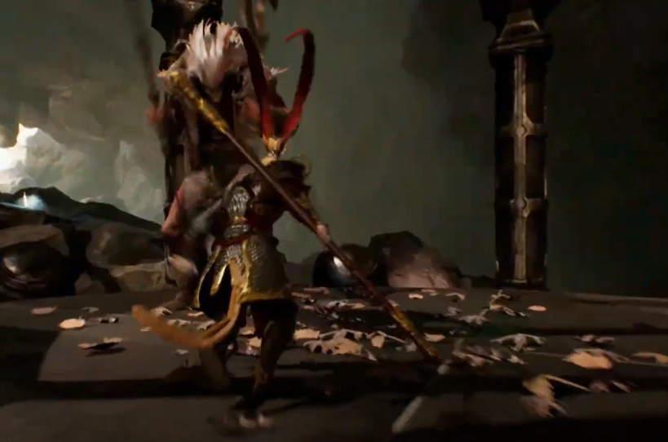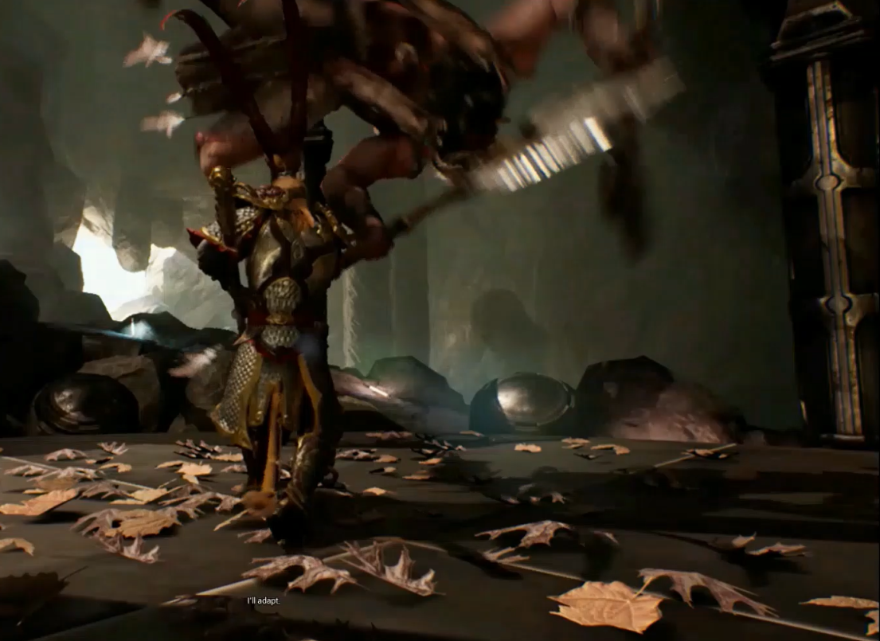

**Motion Editing: Blending and Transplanting**.

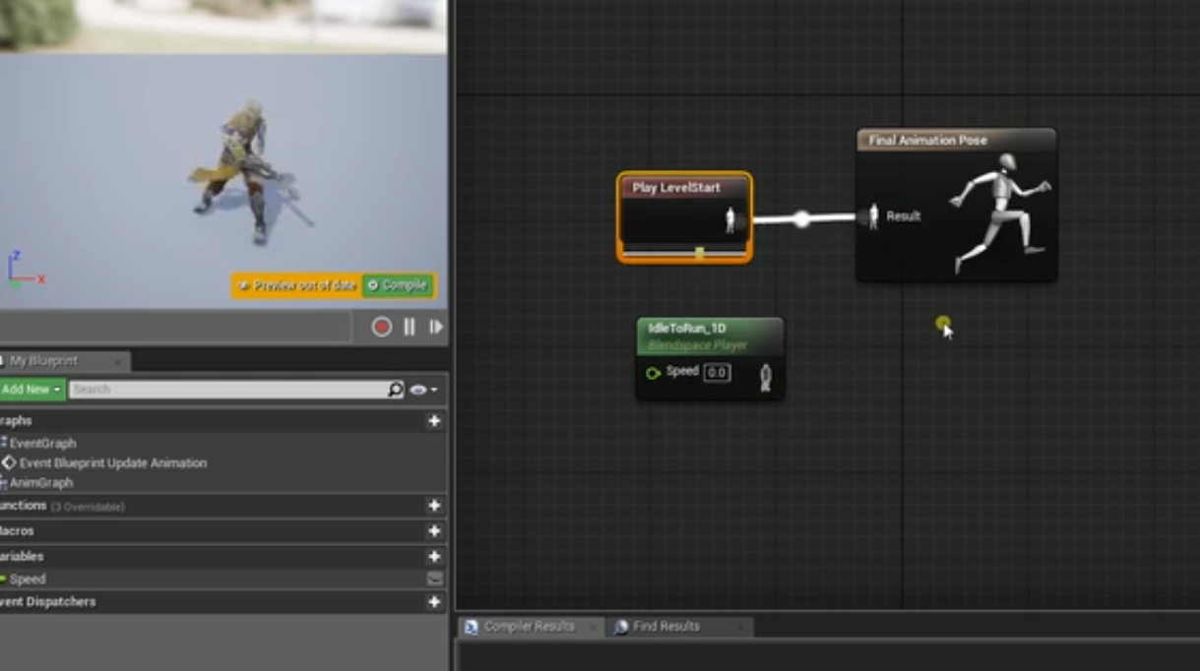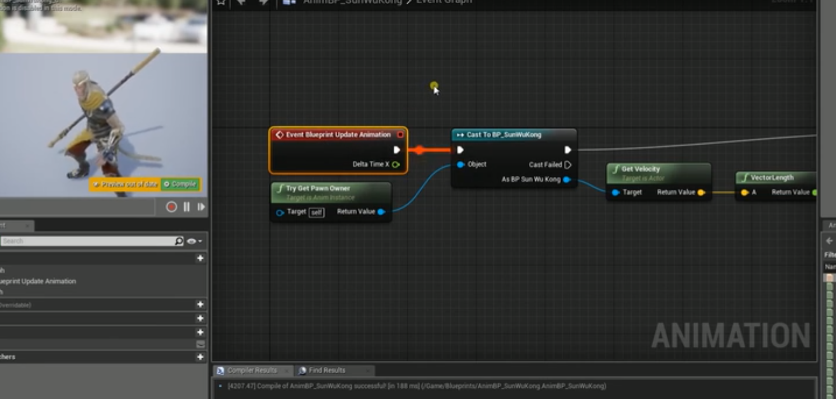





**Complex Camera motion:**

I have wrote the blueprint to let the camera follow the character and stay in a stable distance with a flexible angle( yaw, pitch).

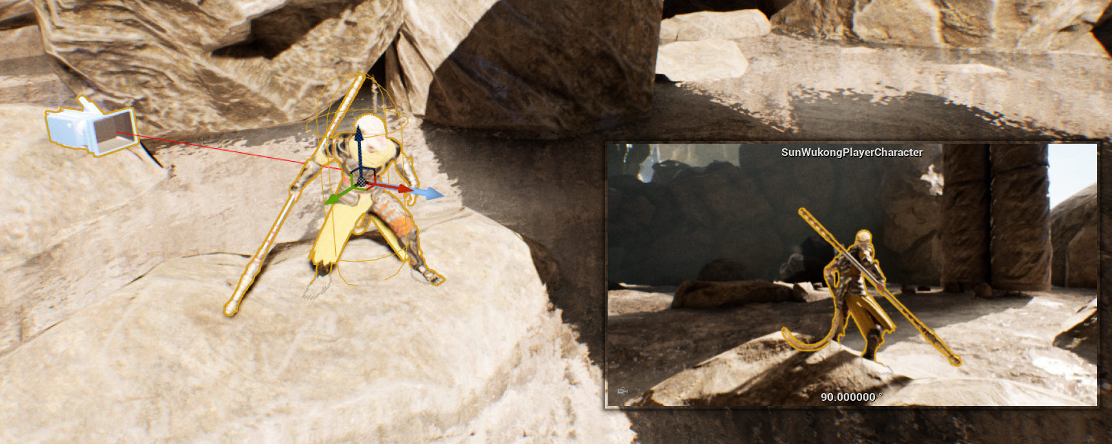

**Interesting Character behaviour/AI**, this is presented especially ate the end of the video while the hero is fighting to the demon.

**Cloth Simulation:**

The Hero, AI enemies and a Goddess, below is an example of the cloth simulation of the Goddess.

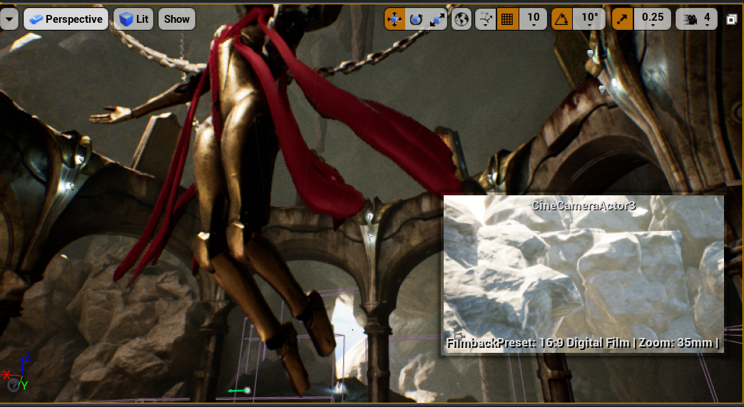

**Particle System**

The fire at the end and the water fall in the middle.

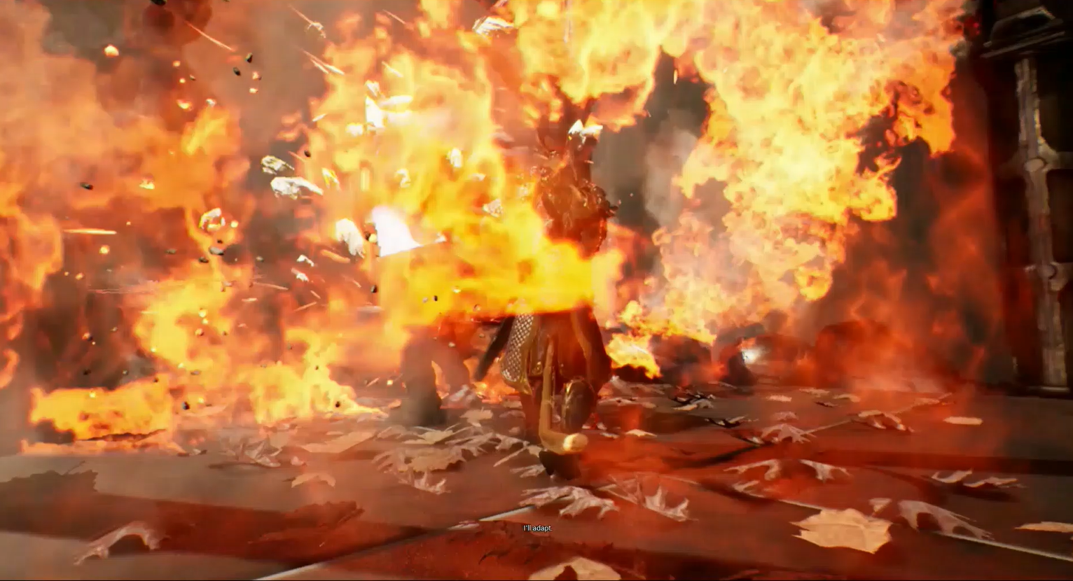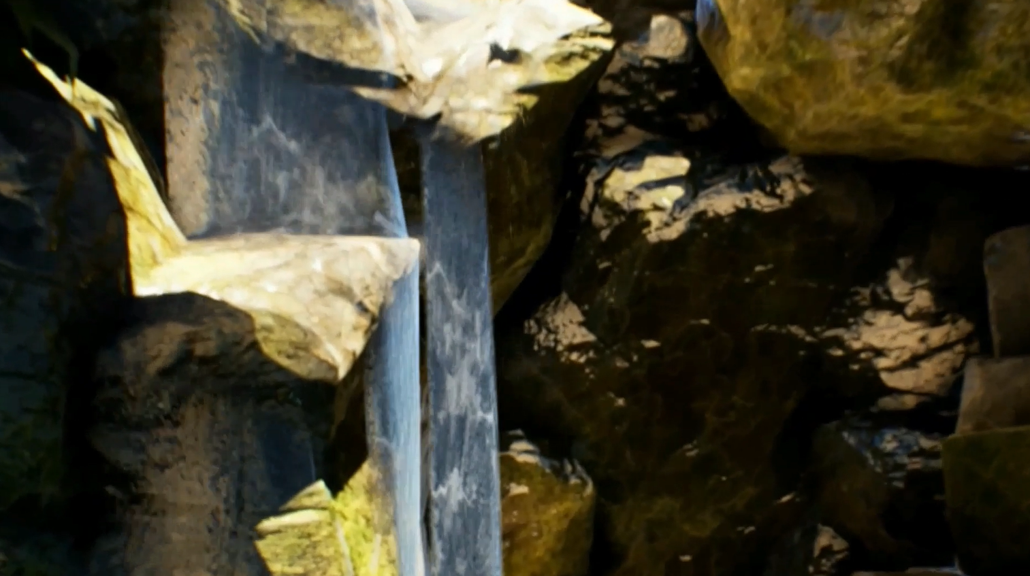

**Physically-Based animation:**

A set of motions of jump of the hero which are start , highest point, and falling down.

**Resources Utilized:**

Dissertation:

Masaki Oshita 2003, A Study on Physics-Based Real-Time Human Animation from Kyushu University

[www.cg.ces.kyutech.ac.jp/paper/oshita_dissertation.pdf](http://www.cg.ces.kyutech.ac.jp/paper/oshita_dissertation.pdf)

Book:

[(2016) OpenGL Programming Guide (PDF) The Official Guide to Learning… (slideshare.net)](https://www.slideshare.net/xylogoco72901/2016-opengl-programming-guide-pdf-the-official-guide-to-learning-opengl-version-45-with-spirv-9th-edition-by-john-kessenich-addisonwesley-professional)

Assets:

Character Sun Wukong from Unreal Engine 4

Character Khaimera from Unreal Engine4

Character ThirdPerson from Unreal Engine4

Scene LVCave from Unreal Engine 4

Tutorials:

[How to get started with Ready Player Me Unreal Engine 4 Avatar SDK](https://readyplayer.me/blog/3d-avatars-unreal-engine-4-sdk-get-started)

[Welcome to Unreal Engine 5 Early Access - YouTube](https://www.youtube.com/watch?v=d1ZnM7CH-v4)

[UE4 Tutorial - How To Use Timelines - YouTube](https://www.youtube.com/watch?v=rTCLEg697z0&t=21s)

Unreal Engine Chinese Tutorial[虚幻引擎动画教程（合集版）_哔哩哔哩_bilibili](https://www.bilibili.com/video/BV1Ly4y1q7UG?p=4&spm_id_from=pageDriver)

[How To Create AI And Enemy Basics - #42 Unreal Engine 4 Beginner Tutorial Series - YouTube](https://www.youtube.com/watch?v=3GV6-4uhkYc)

[Unreal Engine AI with Behavior Trees | Unreal Engine - YouTube](https://www.youtube.com/watch?v=iY1jnFvHgbE)

[How to create cinematics inside Unreal Engine - YouTube](https://www.youtube.com/watch?v=-NmHXAFX-3M)

[12 Principles of Animation - YouTube](https://www.youtube.com/playlist?list=PL-bOh8btec4CXd2ya1NmSKpi92U_l6ZJd)